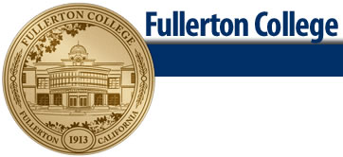 **FASHION DESIGN**

**Fashion Design Certificate**

The Fashion Design Certificate Program is designed to prepare students for entry-level employment in the field of the apparel industry as a worker in the design room. This certificate requires the completion of 37-39 units of which 33 units are in required courses. An additional 4-6 units must be chosen from the restricted electives listed below. A minimum grade of “C” is required for all courses.



Terms Courses Offered may be subject to change, refer to the schedule of courses.

Key: Fall Semester, Spring semester, Every other year