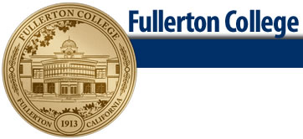 **FASHION DESIGN**

|  |
| --- |
|  |
| **Dressmaking-Alterations Certificate** |
|  |
| The Dressmaking-Alterations Certificate Program prepares students for entry-level employment as a professional in the fields of dressmaker, garment construction, fit and alterations specialist. The program requires the student to complete 36 units of required courses. |
|  |



Terms Courses Offered may be subject to change, refer to the schedule of courses.

Key: Fall Semester, Spring semester, Every other year